# **Assignment #1**

Develop the following form using HTML, CSS and JavaScript. There should be form validation also.

|  |  |  |  |  |  |  |  |
| --- | --- | --- | --- | --- | --- | --- | --- |
|  |  |  |  |  |  |  |  |
| Select your source : | | | Google Cloud Storage | | |  |  |
|  |  |  |  |  |  |  |  |
| Provide a name for pipeline: | | |  | e.g., cust_shop_energy_gateway001 | | |  |
|  |  |  |  |  |  |  |  |
| GCS project name : | | |  | project-id |  |  |  |
|  |  |  |  |  |  |  |  |
| GCS bucket name : | | |  | gs://your-bucket | | |  |
|  |  |  |  |  |  |  |  |
| Input Cloud Storage File(s) : | | |  | GCS location of your files | | |  |
|  |  |  |  | Example: gs://your-bucket/your-files/01.csv |  |  |  |
| GCS credentials : | | |  |  |  |  |  |
|  |  |  |  |  |  |  |  |
| Run Every : | | |  | (in minutes) |  |  |  |
|  |  |  |  |  |  |  |  |
|  |  | Create |  | Cancel |  |  |  |
|  |  |  |  |  |  |  |  |

**Form:**

Evaluation criteria for Assignment #1: Look and Feel. Should have below mentioned validations for all the box:

Minimum length 5. No special characters. Cannot start with '-', '_', '+'

**HTML,CSS and JS Code :--**

<!DOCTYPE html>

<html lang="en">

<head>

    <meta charset="UTF-8">

    <meta name="viewport" content="width=device-width, initial-scale=1.0">

    <title>Task 1 Everlytics </title>

    <style>

        body {

            text-align: center;

        }

        label {

            margin-top: 10px;

            padding-top: 10px;

        }

        input {

            width: 50%;

            margin-top: 10px;

            background-color: lightsteelblue;

            padding: 5px 10px;

        }

        input::placeholder {

            color: gray;

        }

        button {

            background-color: #008CBA;

            color: white;

            padding: 15px 32px;

            text-align: center;

            display: inline-block;

            font-size: 16px;

            margin-top: 10px;

        }

        button:hover {

            background-color: lightsteelblue;

        }

    </style>

</head>

<body>

    <form id="form"

        style="border: solid black 2px; display:inline-block; padding: 10px 10px 10px 10px; margin: 10px 10px 10px 10px;">

        <label for="selectile">

            Select your source:

            <input type="file" class="input">

        </label>

        <br>

        <br>

        <label for="nameforpipeline">

            Provide a name for pipeline:

            <input type="text" name="nameforpipeline" placeholder="e.g., cust_shop_energy_gateway001" class="input"

                id="pipeline">

        </label>

        <br>

        <br>

        <label for="GCS_project_name">

            GCS project name:

            <input type="text" placeholder="project-id" class="input" id="projectName">

        </label>

        <br>

        <br>

        <label for="GCS_bucket_name">

            GCS bucket name :

            <input type="text" placeholder="gs://your-bucket" class="input" id="bucketName">

        </label>

        <br>

        <br>

        <label for="Input_Cloud_Storage_File">

            Input Cloud Storage File(s) :

            <input type="text" placeholder="GCS location of your files" class="input" id="cloudStorage">

            <br>

            <span style="margin-left: 190px; color: #cdcdcd;">

                Example: gs://your-bucket/your-files/01.csv</span>

        </label>

        <br>

        <br>

        <label for="GCS_credentials">

            GCS credentials :

            <input type="text" id="credentials">

        </label>

        <br>

        <br>

        <label for="Run_every">

            Run every:

            <input type="text" placeholder="(in minutes)" class="input">

        </label>

        <br>

        <br>

        <button type="submit" onclick="validate()" id="submit">Create</button>

        <button type="reset" style="width:50%">Cancel</button>

        <br>

        <br>

        <hr>

    </form>

    <script>

        function validate() {

var inputv = document.getElementsByClassName("input")

var a = document.getElementById("pipeline").value

var b = document.getElementById("projectName").value

var c = document.getElementById("bucketName").value

var d = document.getElementById("credentials").value

var e = document.getElementById("cloudStorage").value

if (a.length < 5 || b.length < 5 || c.length < 5 || d.length < 5 || d.length < 5) {

    alert("Your input length should be greater than 5")

    // document.getElementsById("form").style.border="2px solid red"

}

else if (/[^a-zA-Z0-9\-\/]/.test(a)) {

    alert('No special character allowed');

    return false;

}

else if (/[^a-zA-Z0-9\-\/]/.test(b)) {

    alert('No special character allowed');

    return false;

}

else if (/[^a-zA-Z0-9\-\/]/.test(c)) {

    alert('No special character allowed');

    return false;

}

else if (/[^a-zA-Z0-9\-\/]/.test(d)) {

    alert('No special character allowed');

    return false;

}

else if (/[^a-zA-Z0-9\-\/]/.test(e)) {

    alert('No special character allowed');

    return false;

}

}

    </script>

</body>

</html>

**Output:-** 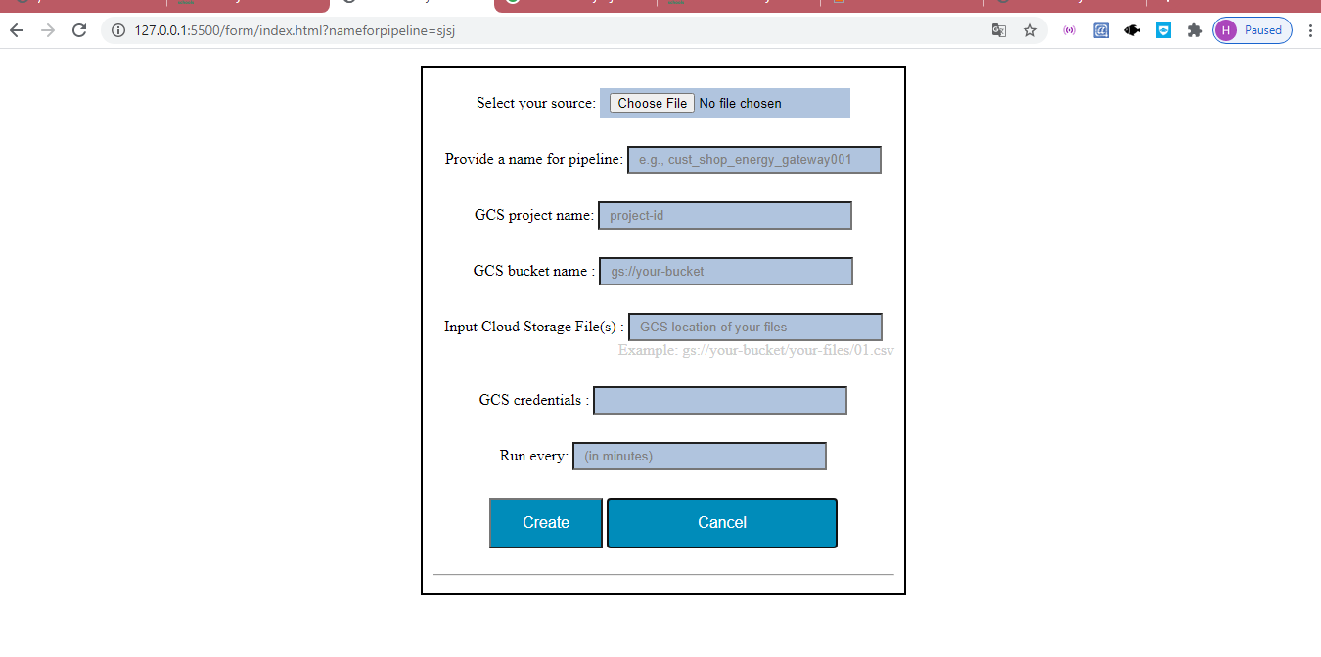

# 

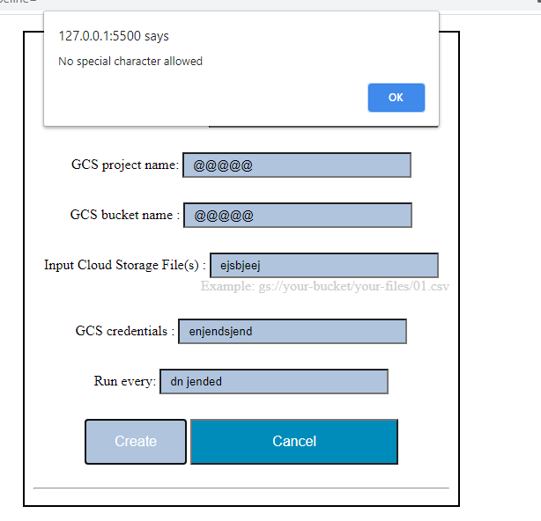

# **Assignment #2**

Develop the following table using Javascript. The data for the table should come from a JSON file stored on the server.

The specific requirement here is to make sure the table is built dynamically using JS (but not statically using HTML). If built that way the table should get updated automatically (upon page refresh) when the data in the underlying JSON file changes.

**Table:**

<https://drive.google.com/file/d/1YQMqa0Cy6frIXBhKST6moXaQ26pp4B43/view?usp=shari>**ng**

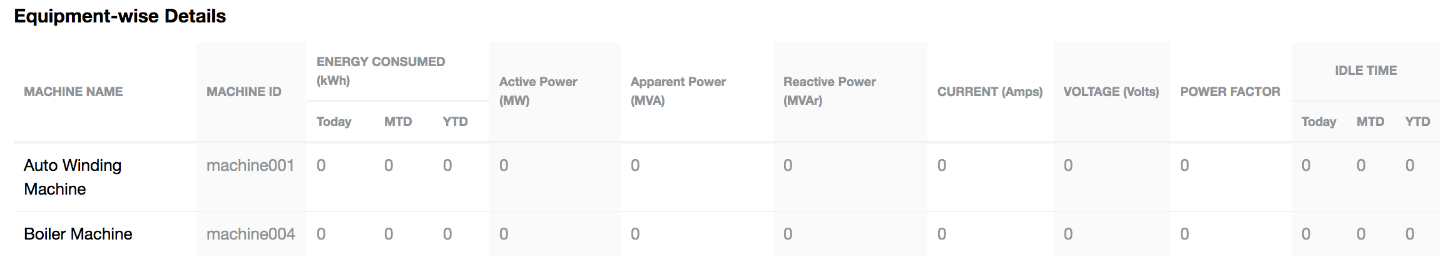

**JSON file:**

[[machine_name,machine_id,current,voltage,power_factor,active_power,apparent_power,reactive_power,daily_energy,monthly_energy,yearly_energy,idle_daily,idle_monthly,idle_yearly], [“Auto Winding Machine”, “machine001", 0, 0, 0, 0.0, 0.0, 0.0, 0, 0, 0, 0, 0, 0], [“Boiler Machine”, “machine004", 0, 0, 0, 0.0, 0.0, 0.0, 0, 0, 0, 0, 0, 0]]

Evaluation criteria for Assignment #2: Ability to use Javascript and JSON to produce a dynamic table. Please note, Look and Feel is not the evaluation criteria for this assignment.

**Code:- HTML and JS FILE**

<!DOCTYPE html>

<html lang="en">

<head>

    <meta charset="UTF-8">

    <meta name="viewport" content="width=device-width, initial-scale=1.0">

    <title>json</title>

    <script src="https://ajax.googleapis.com/ajax/libs/jquery/3.5.1/jquery.min.js"></script>

<style>

    table,th,td{

        padding: 3px;

        row-gap: 2;

        font-family: 'Lucida Sans', 'Lucida Sans Regular', 'Lucida Grande', 'Lucida Sans Unicode', Geneva, Verdana, sans-serif;

    }

    th{

        text-transform:uppercase;

    }

    tr td:nth-child(even){

        background-color: #cdcdcd;

    }

</style>

</head>

<body>

    <h1>Task2</h1>

    <input type="button" onclick="CreateTableFromJSON()" value="Click here to create dynamic table " />

    <p id="showTable"></p>

    <script>

        function CreateTableFromJSON() {   //function to create dynamic table

            var xmlhttp = new XMLHttpRequest();             //to get the dat from json

            var url = "user.json";   //json file url

            xmlhttp.onreadystatechange = function () {

                if (this.readyState == 4 && this.status == 200) {

                    //parsed the data from json to use it

                    var response = JSON.parse(xmlhttp.responseText)

                    console.log(response[1])

                    // for (var i = 0; i <= response.length; i++) {

                    //     console.log(response[i])

                    // }

                    var col = []; //for 2d table

                    for (var i = 0; i < response.length; i++) {

                        for (var key in response[i]) {

                            if (col.indexOf(key) === -1) {

                                //if key is not present there then pushing it

                                //key will form heading(th3) of table

                                col.push(key);

                            }

                        }

                    }

                    // creating dynamic table

                    var table = document.createElement("table");

                    var tr = table.insertRow(-1);                   // TABLE ROW.

                    for (var i = 0; i < col.length; i++) {

                        var th = document.createElement("th");      // TABLE HEADER.

                        th.innerHTML = col[i];

                        tr.appendChild(th);

                    }

                    // ADD JSON DATA TO THE TABLE AS ROWS.

                    for (var i = 0; i < response.length; i++) {

                        tr = table.insertRow(-1);

                        for (var j = 0; j < col.length; j++) {

                            var tabCell = tr.insertCell(-1);

                            tabCell.innerHTML = response[i][col[j]];

                        }

                    }

                    var divContainer = document.getElementById("showTable");

                    divContainer.innerHTML = "";

                    divContainer.appendChild(table);

                }

            }

            xmlhttp.open("GET", url, true);

            xmlhttp.send();

        }

    </script>

    </div>

</body>

</html>

JSON FILE

[

    {

        "machine_name":"Auto Winding Machine",

        "machine_id":"machine001",

        "current":0,

        "voltage":0,

        "power_factor":0,

        "active_power":0,

        "apparent_power":0,

        "reactive_power":0,

        "daily_energy":0,

        "monthly_energy":0,

        "yearly_energy":0,

        "idle_daily":0,

        "idle_monthly":0,

        "idle_yearly":0

    },

      {"machine_name":"Boiler Machine",

        "machine_id":"machine004",

        "current":0,

        "voltage":0,

        "power_factor":0,

        "active_power":0,

        "apparent_power":0,

        "reactive_power":0,

        "daily_energy":0,

        "monthly_energy":0,

        "yearly_energy":0,

        "idle_daily":0,

        "idle_monthly":0,

        "idle_yearly":0

      }

    ]

Output :- 